Quantum Variational Generative Models

1. Problem
Generative models aim to learn an underlying probability distribution from data in order to generate new samples. Classical approaches include variational autoencoders (VAEs), GANs, and energy-based models.
Quantum Variational Generative Models (QVGM) seek to use parameterized quantum circuits (variational circuits) to represent and learn complex probability distributions, potentially exploiting quantum superposition and entanglement to model correlations more efficiently.

2. Intuition
The key idea behind quantum variational generative models is:
- A parameterized quantum circuit prepares a quantum state (|())
- Measuring the circuit produces samples
- The circuit parameters () are trained to match a target data distribution
Unlike GANs, there is often no adversary; instead, training minimizes a divergence between the model distribution and the data distribution.

3. Model / Circuit Structure

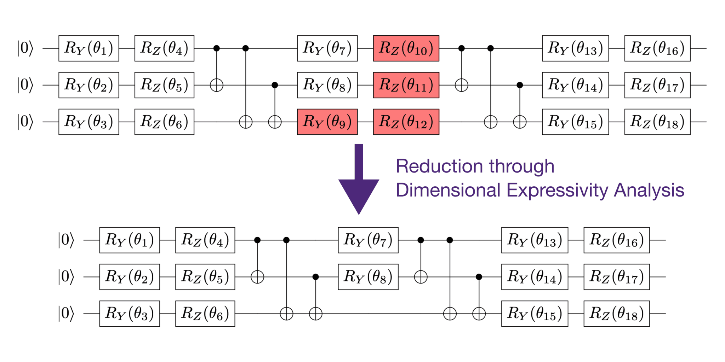
A typical quantum variational generative model consists of:
- Initialization
Qubits are initialized in the (|0) state.
- Variational Ansatz
Layers of trainable single-qubit rotations and entangling gates.
- Measurement
Measuring all qubits yields samples from the learned distribution.
- Classical Optimization Loop
Classical optimizer updates circuit parameters based on a cost function.

4. Simple Math Involved
- State preparation: [ |()= U()|0 ]
- Model distribution (Born rule): [ p_(x) = |x | () |^2 ]
- Training objective: [ D(p{} || p_) ]
where (D) may be KL divergence, maximum mean discrepancy (MMD), or another statistical distance.

5. Python Code (Quantum Variational Generative Model – Qiskit)
Platform-agnostic, copy-paste-ready Qiskit implementation
import numpy as np
from qiskit import QuantumCircuit
from qiskit.circuit.library import RealAmplitudes
from qiskit.primitives import Sampler
num_qubits = 3
ansatz = RealAmplitudes(num_qubits, reps=2)
qvgm = QuantumCircuit(num_qubits)
qvgm.compose(ansatz, inplace=True)
qvgm.measure_all()
sampler = Sampler()
job = sampler.run(qvgm, shots=2048)
result = job.result()
distribution = result.quasi_dists[0]
print("Generated probability distribution:")
for bitstring, prob in distribution.items():
print(bitstring, prob)

6. Where the Algorithm Is Useful
- Generative modeling
- Quantum data generation
- Learning complex probability distributions
- Benchmarking quantum sampling capabilities

7. Limitations
- Training can be slow due to sampling noise
- Barren plateaus may occur
- No guaranteed quantum advantage
- Limited scalability on current NISQ devices

8. Comparison with Classical Variational Models
- Model: Classical VAEs use neural networks; quantum models use quantum circuits
- Sampling: Classical sampling vs. quantum measurement
- Expressivity: Quantum circuits may capture correlations differently
- Maturity: Classical variational models are well-established; quantum models are experimental

9. One-Sentence Summary
Quantum Variational Generative Models use trainable quantum circuits to learn and sample from probability distributions via quantum measurement.

